PROJECT DOCUMENTATION
1. INTRODUCTION
1.1 Project Title
Sports Hall Booking System using ServiceNow Service Portal
1.2 Team Member
Although the project documentation template is designed for team projects, this project was completed individually as part of the SmartBridge ServiceNow Internship Program.
Team Member | Role / Responsibility
Veldurthi Hemanth | Requirement Analysis, UI Design, Service Portal Development, Client-side Scripting, Server-side Scripting, Database Design, Testing, Documentation and Deployment

1.3 Project Introduction
The Sports Hall Booking System using ServiceNow Service Portal is a web-based application developed during the SmartBridge internship to automate the process of sports hall reservations. Traditionally, sports hall bookings are managed manually, resulting in booking conflicts, duplicate reservations, lack of transparency, and increased administrative effort.
The developed application provides an online booking platform where users can reserve sports halls by selecting a sport, choosing a booking date, viewing available one-hour time slots, and confirming the reservation. The system automatically checks slot availability, prevents duplicate bookings, calculates booking charges, and securely stores booking information in the ServiceNow database.
The application has been developed using ServiceNow's low-code development platform by utilizing Service Portal, Widgets, Client Controllers, Server Scripts, GlideRecord API, Business Rules, Flow Designer, Notifications, Events, and Scheduled Jobs.
The project demonstrates how ServiceNow can be used to build enterprise-level applications beyond traditional IT Service Management while improving the efficiency of sports facility management.

2. PROJECT OVERVIEW
2.1 Purpose
The main purpose of the Sports Hall Booking System is to digitize and simplify the sports hall reservation process. The system allows users to reserve sports facilities online without visiting the sports office physically.
The application aims to:
- Automate sports hall booking.
- Eliminate manual booking registers.
- Display real-time slot availability.
- Prevent duplicate bookings.
- Maintain booking records securely.
- Improve user convenience.
- Reduce administrative workload.

2.2 Project Objectives
The major objectives of the project are:
- Develop an online sports hall booking application using ServiceNow.
- Allow users to book available sports halls through the Service Portal.
- Automatically calculate booking charges.
- Display only available booking slots.
- Prevent duplicate bookings using server-side validation.
- Store booking information securely.
- Provide an easy-to-use and responsive user interface.

2.3 Key Features
The Sports Hall Booking System includes the following features:
- Sports selection through dropdown.
- Booking date selection.
- Dynamic display of available slots.
- Automatic booking charge calculation.
- Duplicate booking prevention.
- Secure booking storage.
- Booking confirmation.
- User-friendly interface.
- Contact page.
- My Bookings page.
- Responsive Service Portal.
2.4 Technologies Used
Technology | Purpose
ServiceNow Personal Developer Instance | Development Platform
Service Portal | User Interface
HTML | Widget Layout
CSS | Styling
AngularJS | Client Controller
JavaScript | Client-side Logic
Server Script | Backend Processing
GlideRecord API | Database Operations
Business Rules | Server-side Validation
Flow Designer | Workflow Automation
Email Notifications | Booking Notifications
Event Registry | Trigger Notifications
Scheduled Job | Reminder Execution

3. SYSTEM ARCHITECTURE
The Sports Hall Booking System follows a three-layer architecture consisting of the Presentation Layer, Business Logic Layer, and Database Layer.

3.1 Frontend Architecture
The frontend of the application is developed using the ServiceNow Service Portal. The portal provides an interactive interface that allows users to reserve sports halls quickly and efficiently.
The frontend consists of the following components:
- Sports Zone Portal
- Home Page
- Book Venue Page
- My Bookings Page
- Contact Page
- Book Venue Widget
- HTML Template
- CSS Styling
- AngularJS Client Controller
The Client Controller communicates with the Server Script to retrieve available booking slots dynamically without refreshing the page.

3.2 Backend Architecture
The backend is implemented using ServiceNow Server Scripts and GlideRecord APIs.
The backend is responsible for:
- Processing booking requests.
- Retrieving available booking slots.
- Preventing duplicate bookings.
- Calculating booking charges.
- Validating booking information.
- Saving booking records.
- Returning booking confirmation.
The Server Script communicates directly with the ServiceNow database through GlideRecord.
3.3 Database Architecture
The application stores all booking information inside a custom ServiceNow table.
Table Name
Sports Hall Bookings
The table stores all booking-related information including sport name, booking date, booking time, booking charge, payment status, booking status, and user information.
Main Fields
Field Name | Purpose
Hall Name | Selected Sport
Start Time | Booking Start Time
End Time | Booking End Time
Booking Charge | Sports Booking Charge
Booking Status | Pending / Approved / Completed
Payment Status | Pending / Paid
Booked By | Logged-in User

3.4 Architecture Workflow
User
│
▼
Sports Zone Service Portal
│
▼
Book Venue Widget
│
▼
Client Controller
│
▼
Server Script
│
▼
GlideRecord API
│
▼
Sports Hall Booking Table
│
▼
Booking Confirmation

4. SETUP INSTRUCTIONS
4.1 Development Environment
The Sports Hall Booking System was developed using the ServiceNow Personal Developer Instance (PDI). The application was implemented using Service Portal, custom tables, widgets, server-side scripting, and workflow automation provided by the ServiceNow platform.

4.2 Prerequisites
Before implementing the project, the following prerequisites are required:
Software / Tool | Purpose
ServiceNow Personal Developer Instance (PDI) | Development Platform
Service Portal Plugin | Portal Development
Flow Designer | Workflow Automation
Event Registry | Event Management
Email Notifications | Booking Notifications
Scheduled Jobs | Reminder Automation
Google Chrome / Microsoft Edge | Web Browser
Internet Connection | Access ServiceNow Instance

4.3 Project Setup
The following steps were performed to develop the project.
Step 1: Create ServiceNow Personal Developer Instance
- Register on the ServiceNow Developer Portal.
- Activate a Personal Developer Instance (PDI).

Step 2: Create Custom Application
A custom application named
Sports Hall Booking System
was created using App Engine Studio.

Step 3: Create Custom Table
Created a custom table:
Sports Hall Bookings
This table stores all booking-related information.

Step 4: Create Required Fields
The following fields were created inside the custom table.
Field Name | Type
Hall Name | Choice
Start Time | Date/Time
End Time | Date/Time
Booking Charge | Integer
Payment Status | Choice
Status | Choice
Booked By | Reference (User)

Step 5: Configure Service Portal
Created a Service Portal named
Sports Zone
Portal Configuration
Property | Value
Portal Name | Sports Zone
URL Suffix | sz
Theme | La Jolla
Home Page | sports_booking

Step 6: Create Portal Pages
The following Service Portal pages were created.
Page | Purpose
Home | Landing Page
Book Venue | Sports Hall Booking
My Bookings | View Existing Bookings
Contact | Contact Information
Administrator Dashboard | To manage halls, sports, user approvals

Step 7: Develop Service Portal Widgets
Widgets are the core building blocks of the ServiceNow Service Portal. A custom widget named Book Venue was developed to provide the complete sports hall booking functionality. The widget consists of four major components: HTML, CSS, Client Controller, and Server Script.
Widget Components
- HTML Template
  - Designed the booking form.
  - Added sports selection dropdown.
  - Added booking date picker.
  - Displayed available booking slots dynamically.
  - Added Book and Cancel buttons.
  - Displayed booking charges automatically.
- CSS
  - Designed a responsive user interface.
  - Styled booking cards and buttons.
  - Improved portal appearance.
  - Created consistent spacing and alignment.
- Client Controller
  - Handles user interactions.
  - Retrieves available slots from the server.
  - Updates booking charges based on selected sport.
  - Validates user inputs.
  - Sends booking requests to the Server Script.
  - Displays success and error messages.
- Server Script
  - Retrieves available booking slots.
  - Checks existing bookings.
  - Removes already booked slots from the available list.
  - Prevents duplicate bookings.
  - Calculates booking information.
  - Inserts booking records into the database.
  - Returns booking confirmation to the client.

Step 8: Configure Business Rules
Business Rules were created to perform server-side validation and maintain data integrity. These rules automatically execute whenever booking records are inserted or updated.
Business Rules Implemented
Business Rule | Purpose
Validate Booking | Checks whether the selected slot is already booked before saving the record.
Booking Status Validation | Ensures that every booking receives the correct initial status.
Booking Confirmation Trigger | Executes booking-related actions after successful insertion.
Data Integrity Rule | Prevents invalid booking records from being stored.
Functions of Business Rules
- Prevent duplicate bookings.
- Validate booking information.
- Maintain booking consistency.
- Trigger backend processes.
- Improve system reliability.

Step 9: Configure Flow Designer
ServiceNow Flow Designer was used to automate booking-related activities without writing complex server-side logic. Different flows were created to simplify the booking lifecycle.
Flows Created
Flow Name | Purpose
Booking Confirmation Flow | Executes after a booking is successfully created.
Booking Reminder Flow | Sends reminders before the booking time.
Booking Status Flow | Updates booking status automatically during different stages.
Flow Activities
- Detect booking creation.
- Execute automated actions.
- Trigger email notifications.
- Update booking records.
- Improve automation within the application.
Using Flow Designer reduced manual work and improved the efficiency of the booking system.

Step 10: Configure Email Notifications
Email Notifications were configured to provide automatic communication between the system and users whenever important booking events occur.
Notifications Created
Notification | Triggered When
Booking Confirmation | After successful booking creation
Booking Reminder | Before the scheduled booking time
Notification Features
- Automatically generated emails.
- Dynamic booking information.
- User-friendly email format.
- Booking date and time details.
- Sports hall information.
- Booking status information.
The notifications help users stay informed about their reservations without manually checking the portal.

Step 11: Configure Events and Scheduled Job
To automate reminder notifications, custom events and a scheduled job were configured within ServiceNow.
Event Registry
Two custom events were created:
Event Name | Purpose
sports.hall.confirmation | Trigger booking confirmation actions.
sports.hall.reminder | Trigger reminder notifications before the booking time.
The Event Registry acts as a communication mechanism between the application and the notification system.

Scheduled Job
A Scheduled Job was configured to execute automatically at regular intervals.
Its responsibilities include:
- Scanning upcoming bookings.
- Identifying reservations approaching their scheduled time.
- Firing the sports.hall.reminder event.
- Triggering reminder email notifications automatically.
Benefits of Scheduled Job
- Eliminates manual reminder sending.
- Improves user experience.
- Ensures timely notifications.
- Automates repetitive tasks.
- Enhances application reliability.
Step 12: Testing
The complete application was tested for:
- Booking Creation
- Duplicate Booking Prevention
- Slot Availability
- Booking Charges
- User Interface
- Performance

5. PROJECT STRUCTURE
The Sports Hall Booking System consists of multiple ServiceNow components that work together to provide an online booking solution.
5.1 Application Structure

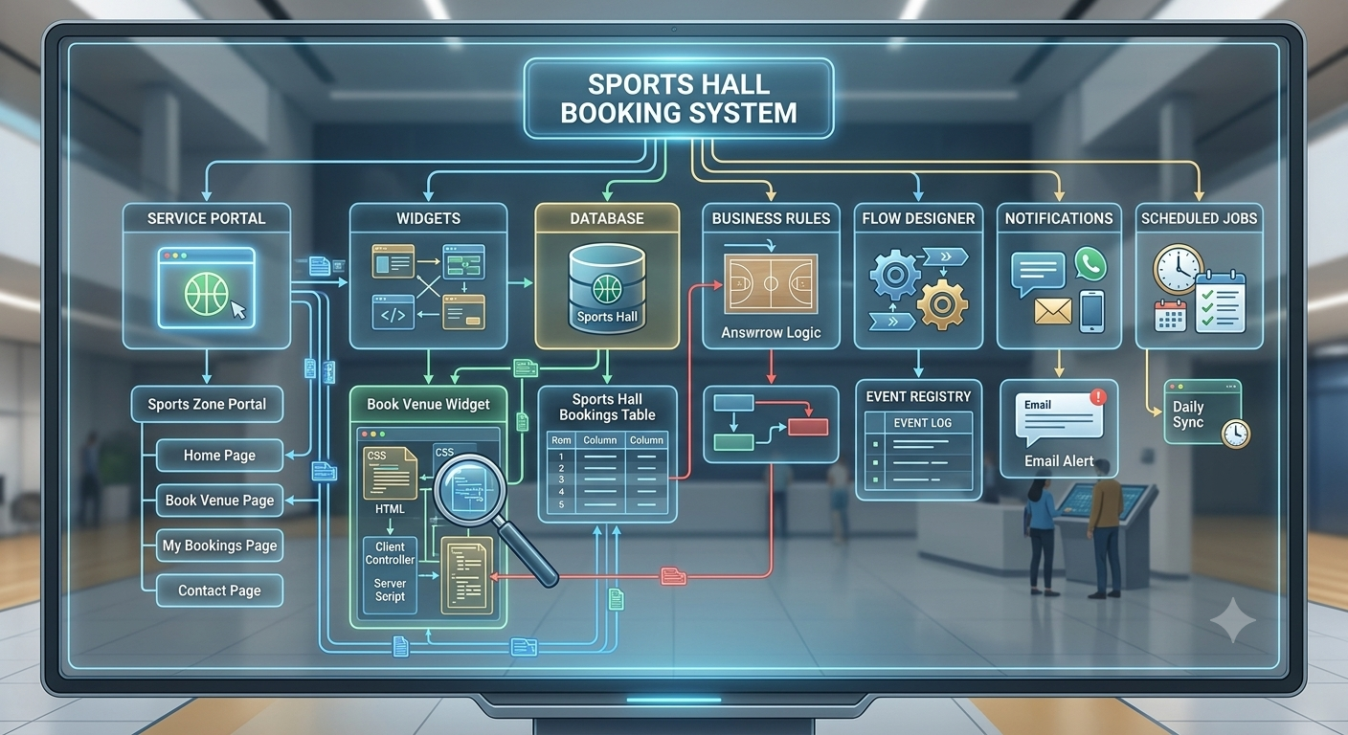
5.2 Service Portal
The Sports Zone Service Portal provides the user interface of the application.
Components
- Sports Zone Portal
- Home Page
- Book Venue
- My Bookings
- Contact

5.3 Widget Structure
The Book Venue Widget is the core component of the application.
It contains four sections.
Component | Purpose
HTML | User Interface
CSS | Styling
Client Controller | Client-side Processing
Server Script | Backend Processing

5.4 Database Structure
The application stores booking records in the custom ServiceNow table.
Table Name
Sports Hall Bookings
Main Information Stored
- Sport Name
- Booking Date
- Start Time
- End Time
- Booking Charge
- Booking Status
- Payment Status
- User Information

5.5 Business Rules
The following Business Rules were implemented.
Business Rule | Purpose
Validate Booking | Prevent duplicate bookings
Booking Processing | Validate booking request
Update Booking Status | Maintain booking status
Booking Confirmation | Trigger booking events

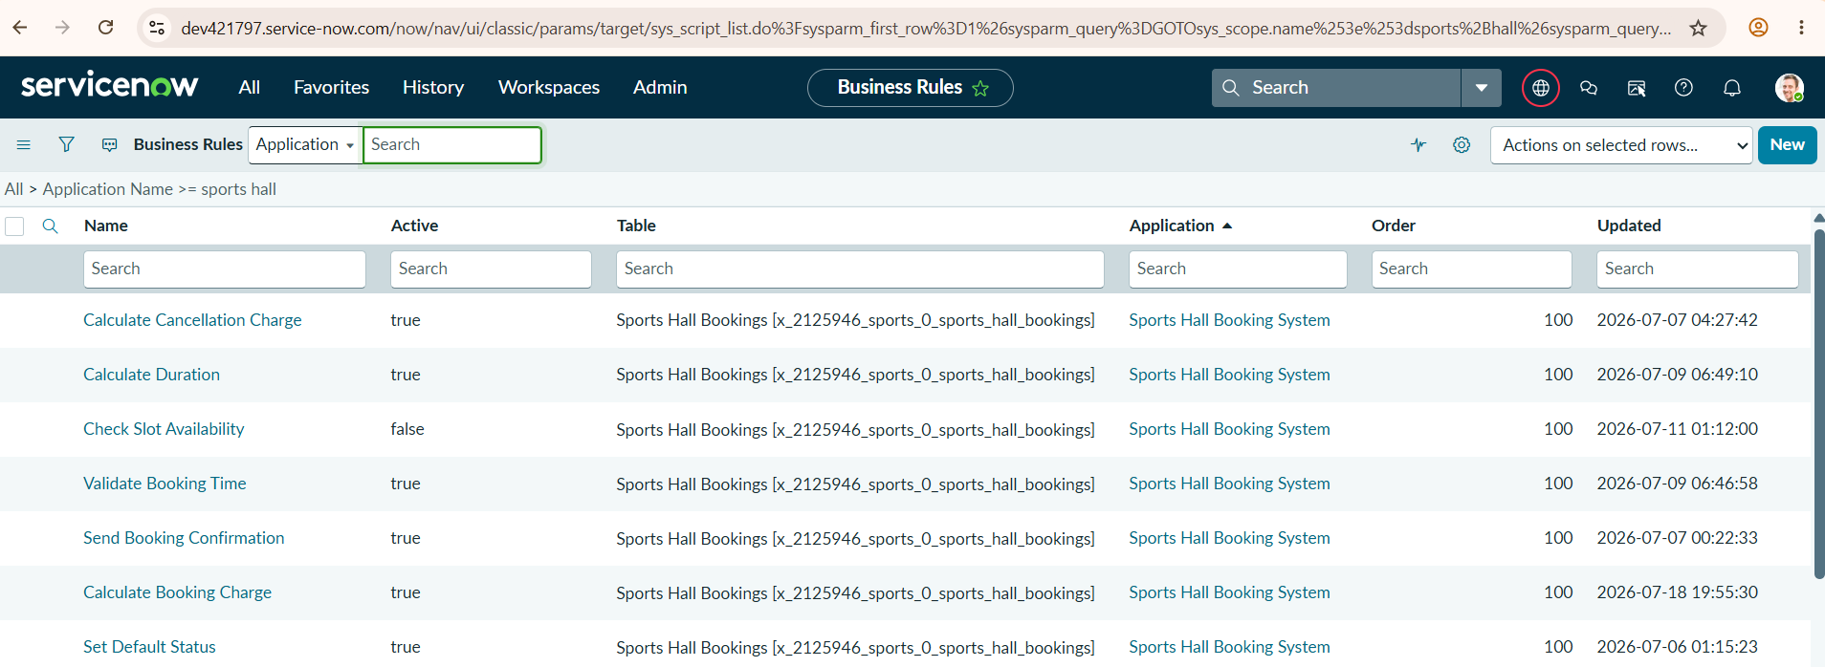
5.6 Flow Designer
Flow Designer automates booking-related processes.
Implemented Flows
- Booking Approval Flow
- Booking Confirmation Flow
- Reminder Flow
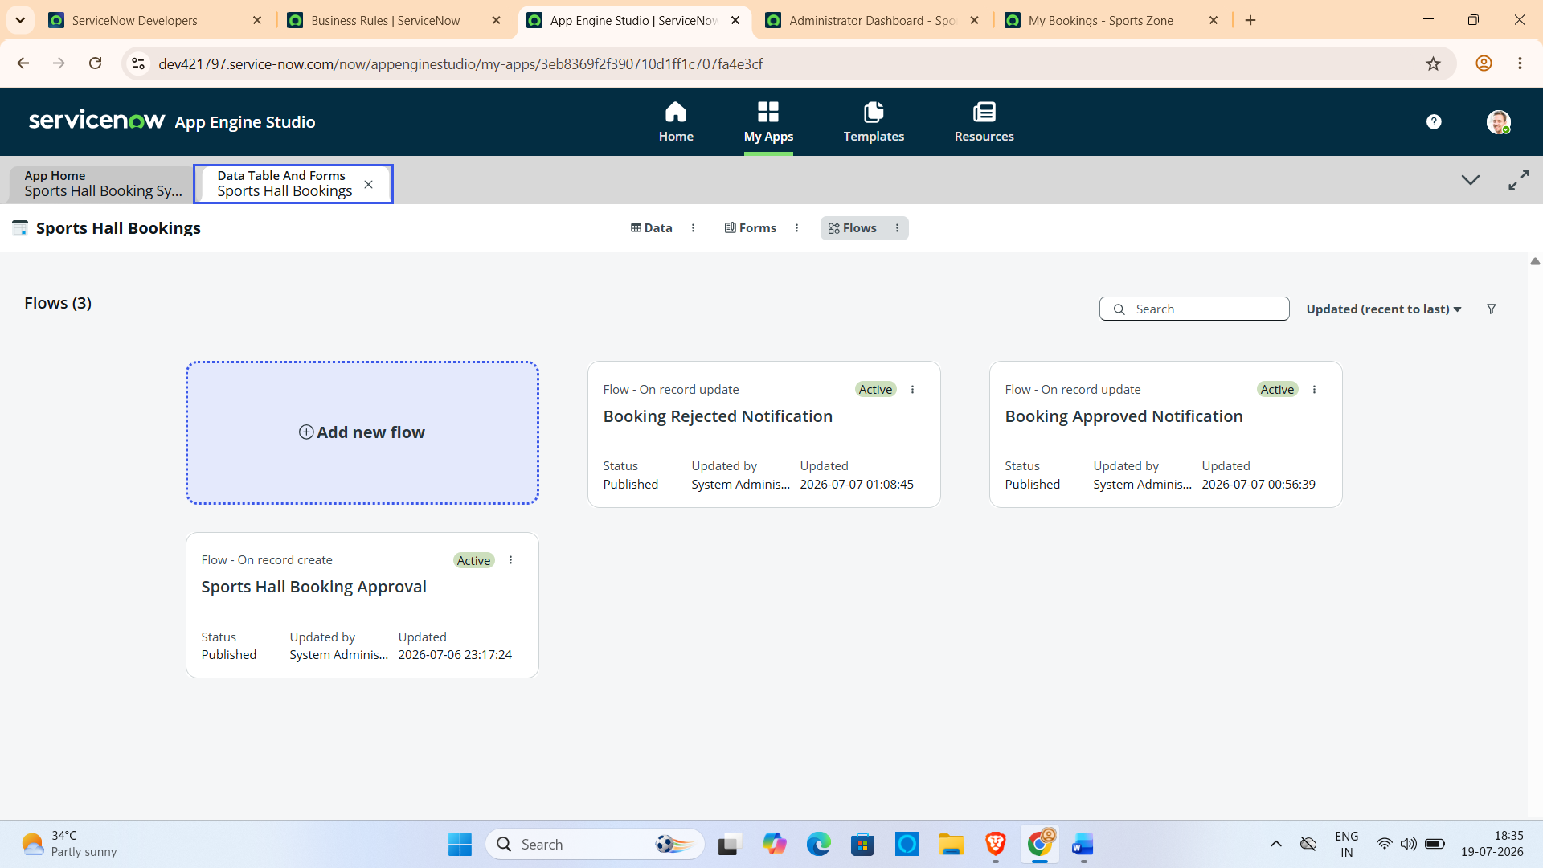

5.7 Event Registry
The following custom events were created.
Event Name | Purpose
sports.hall.confirmation | Booking Confirmation
sports.hall.reminder | Reminder Notification

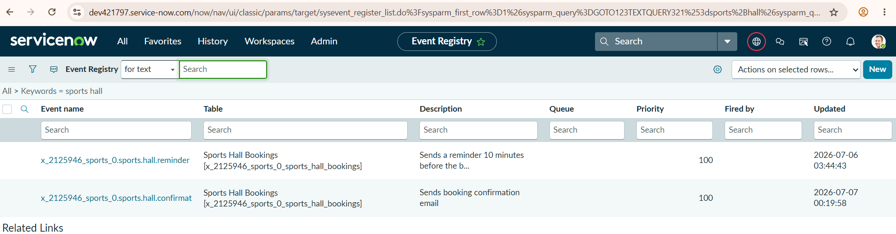
5.8 Notifications
Two email notifications were configured.
Notification | Purpose
Booking Confirmation | Sends confirmation email
Booking Reminder | Sends reminder before booking time

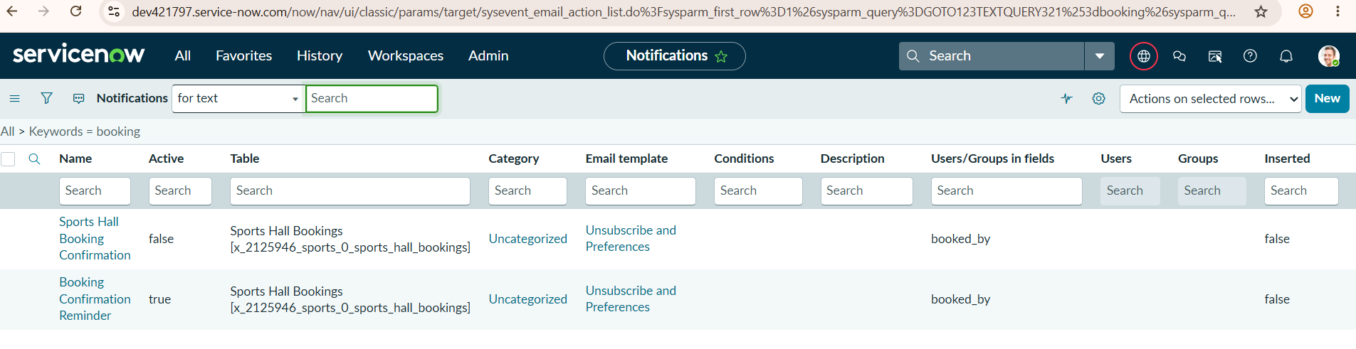
5.9 Scheduled Job
A Scheduled Job executes automatically to send reminder events before the booking time.
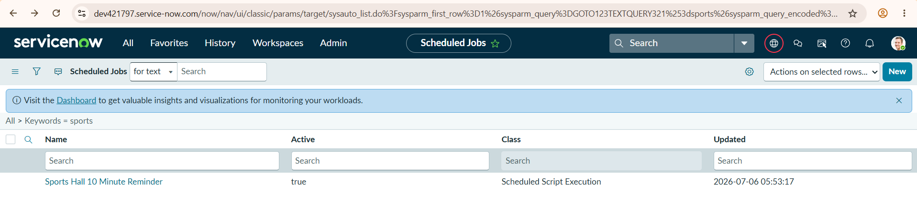
5.10 Overall Workflow
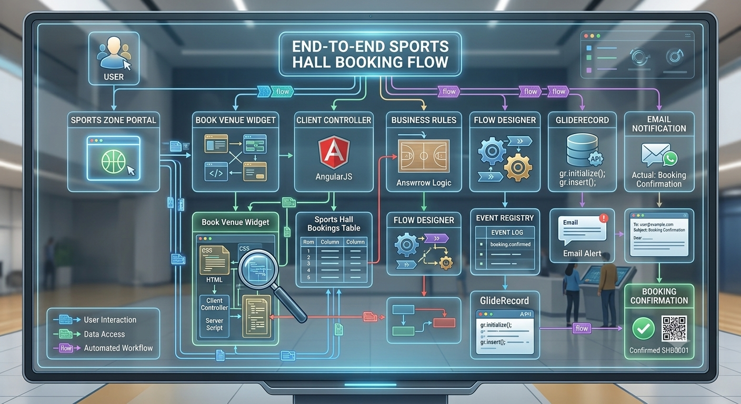
6. RUNNING THE APPLICATION
6.1 Accessing the Application
The Sports Hall Booking System is deployed on the ServiceNow Personal Developer Instance (PDI) and can be accessed through the Sports Zone Service Portal.
Steps to Run the Application
- Open a web browser (Google Chrome or Microsoft Edge).
- Log in to the ServiceNow Personal Developer Instance using valid user credentials.
- Open the Sports Zone Service Portal.
- Navigate to the Book Venue page.
- Select the preferred sport from the dropdown list.
- Choose the booking date.
- View the available booking slots.
- Select an available slot.
- Verify the booking charge.
- Click the Book Now button.
- Receive the booking confirmation message.
- View booking details in the My Bookings page and can cancel if necessary.

6.2 Application Workflow
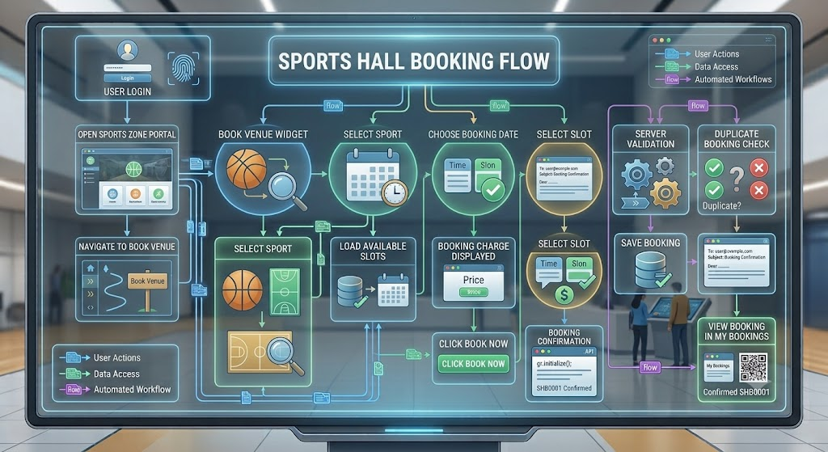
6.3 Modules Executed During Runtime
During execution, the following modules work together:
Module | Function
Service Portal | Displays the application interface
Book Venue Widget | Accepts user booking information
Client Controller | Processes user inputs
Server Script | Performs backend validation
Business Rules | Prevent invalid bookings
GlideRecord | Reads and writes booking records
Database | Stores booking details
Flow Designer | Executes automated workflows
Event Registry | Triggers booking events
Notifications | Sends confirmation and reminder emails

6.4 Runtime Validation
The application performs the following validations while running:
- Checks whether a sport has been selected.
- Validates booking date.
- Loads only available booking slots.
- Prevents duplicate bookings.
- Calculates booking charge automatically.
- Saves only valid booking records.
- Displays appropriate success or error messages.

6.5 Successful Execution
When all validations are completed successfully, the application:
- Creates a new booking record.
- Stores the booking in the Sports Hall Bookings table.
- Displays a booking confirmation message.
- Redirects the user to the Sports Zone home page.
- Makes the booked slot unavailable for future bookings.
- Triggers configured notifications and workflows.

7. API DOCUMENTATION
7.1 Overview
The Sports Hall Booking System uses the ServiceNow Widget framework for communication between the client and server. Instead of traditional REST APIs, the application exchanges data using ServiceNow Widget Server Calls (c.server.get()). The Client Controller sends requests to the Server Script, which processes the request using GlideRecord APIs and returns the appropriate response.
The following operations are implemented in the application.

7.2 Load Available Slots
Purpose
Retrieves all available booking slots for the selected sport and booking date.
Request
Parameter | Type | Description
action | String | loadSlots
hall_name | String | Selected sport
booking_date | Date | Selected booking date
Processing
- Receives sport and booking date.
- Queries the Sports Hall Bookings table.
- Removes already booked slots.
- Removes past time slots (for the current day).
- Returns only available booking slots.
Response
Available Slots

09:00 - 10:00

10:00 - 11:00

13:00 - 14:00

17:00 - 18:00

7.3 Create Booking
Purpose
Creates a new sports hall booking.
Request
Parameter | Type | Description
action | String | book
hall_name | String | Selected sport
booking_date | Date | Booking date
start_time | String | Selected start time
end_time | String | Selected end time
booking_charge | Integer | Booking amount
Processing
The Server Script performs the following operations:
- Validates the booking request.
- Checks duplicate booking.
- Verifies slot availability.
- Creates a new booking record.
- Stores booking details.
- Returns booking confirmation.

Successful Response
Status: Success
Message: Booking Successful
Error Response
Status: Failed

Message: Selected slot is already booked.

7.4 Booking Validation Process
The booking validation process includes the following checks:
- Sport selected.
- Booking date selected.
- Available slot selected.
- Duplicate booking validation.
- Booking charge validation.
- Database insertion.
If all validations are successful, the booking record is created successfully.

7.5 Database Operations
The Server Script performs database operations using the GlideRecord API.
Operations Performed
Operation | Purpose
Query | Retrieve booked slots
Insert | Save booking
Validation | Prevent duplicate bookings
Read | Display available slots
7.6 Request Flow
Client Controller
↓
c.server.get()
↓
Server Script
↓
GlideRecord API
↓
Sports Hall Booking Table
↓
Server Response
↓
Client Controller
↓
User Interface
7.7 Summary
The Sports Hall Booking System uses ServiceNow's built-in server communication mechanism instead of traditional REST APIs. The Client Controller and Server Script work together to retrieve available booking slots, validate booking requests, and store booking records securely. This approach simplifies communication between the user interface and the ServiceNow database while ensuring efficient and reliable booking operations.

8. AUTHENTICATION
8.1 Overview
The Sports Hall Booking System uses the built-in authentication mechanism provided by the ServiceNow platform. Only authenticated users can access the Sports Zone Service Portal and perform booking operations. ServiceNow manages user authentication, authorization, and session handling automatically, ensuring secure access to the application.

8.2 User Authentication
Users must log in to the ServiceNow instance before accessing the Sports Hall Booking System. After successful login, the user is redirected to the Sports Zone Service Portal where booking operations can be performed.
Authentication Process
User
↓
Login to ServiceNow Instance
↓
Username & Password Validation
↓
Authentication Successful
↓
Access Sports Zone Service Portal
↓
Use Booking Services

8.3 User Authorization
The application allows only authenticated users to create and manage bookings. User information is automatically obtained using the ServiceNow session.
During booking creation, the logged-in user's User ID is stored in the Booked By field of the Sports Hall Bookings table.
Authorized Operations
- View Sports Zone Portal
- Select Sport
- Check Available Slots
- Create Booking
- View My Bookings
- Cancel Booking Process

8.4 Session Management
ServiceNow automatically manages user sessions after successful login.
Session management provides the following features:
- Secure login session.
- Automatic session timeout after inactivity.
- User identity maintained throughout the session.
- Secure communication between client and server.
No additional session management code was required because ServiceNow handles it internally.

8.5 User Identification
The application identifies the currently logged-in user using the ServiceNow server-side API.
User Information Retrieved
- User ID
- Username
- User Session
The logged-in user's information is used while creating booking records and maintaining ownership of bookings.

8.6 Data Security
The Sports Hall Booking System follows ServiceNow's security standards to protect booking information.
Security measures include:
- User authentication before accessing the portal.
- Secure storage of booking records.
- Server-side booking validation.
- Prevention of unauthorized booking creation.
- Protection against duplicate bookings.
- Controlled access to booking information.

8.7 Authentication Workflow
User
↓
ServiceNow Login Page
↓
Username & Password Verification
↓
Authenticated User
↓
Sports Zone Service Portal
↓
Booking Operations
↓
Booking Stored with Logged-in User Information
8.8 Advantages of ServiceNow Authentication
- Built-in secure authentication.
- No separate login module required.
- Automatic session management.
- Secure user identification.
- Reliable access control.
- Easy integration with ServiceNow applications.

8.9 Summary
The Sports Hall Booking System relies on the native authentication and authorization mechanisms provided by the ServiceNow platform. Users must log in using valid credentials before accessing the application. ServiceNow automatically manages user sessions, validates user identity, and securely associates booking records with the logged-in user. This approach simplifies development while ensuring secure and reliable access to the booking system.
9. USER INTERFACE
9.1 Overview
The Sports Hall Booking System provides a simple, responsive, and user-friendly interface through the ServiceNow Service Portal. The portal is designed to allow users to reserve sports halls with minimal effort while providing clear navigation between different modules. The interface focuses on ease of use, quick access to booking services, and an organized layout.
The portal consists of four major pages:
- Sports Zone Home Page
- Book Venue Page
- My Bookings Page
- Contact Page
Each page is designed to perform a specific function within the application.

9.2 Sports Zone Home Page
Purpose
The Sports Zone Home Page serves as the landing page of the application. It provides navigation to the various modules available in the Sports Hall Booking System.
Features
- Welcome message
- Project title
- Navigation menu
- Quick access to booking services
- User-friendly layout
- Responsive design
Main Components
- Portal Header
- Navigation Bar
- Home Banner
- Menu Links
- Footer
Screenshot
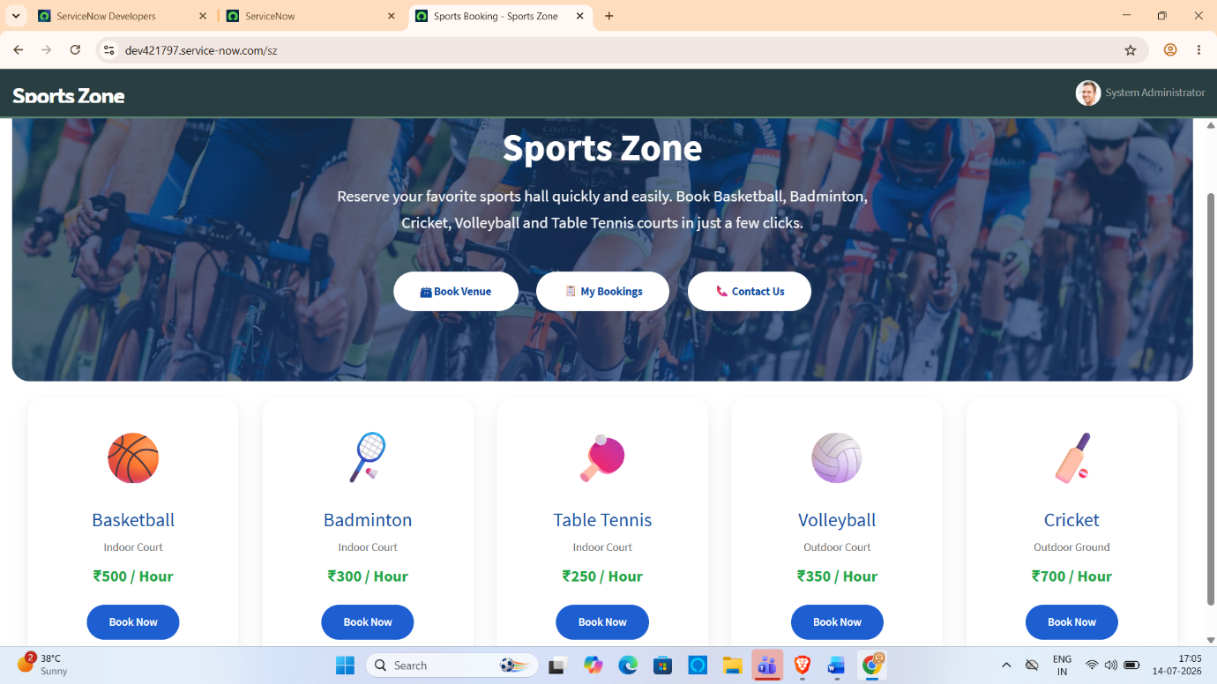

9.3 Book Venue Page
Purpose
The Book Venue page is the core module of the application where users can reserve sports halls.
Features
- Sports selection dropdown
- Booking date selection
- Dynamic booking charge display
- Available slot display
- Book Now button
- Cancel button
- Validation messages
- Booking confirmation
Booking Process
- Select a sport.
- Choose the booking date.
- View available slots.
- Select a slot.
- Verify booking charge. Click Book Now.
- Booking confirmation displayed.
Screenshot
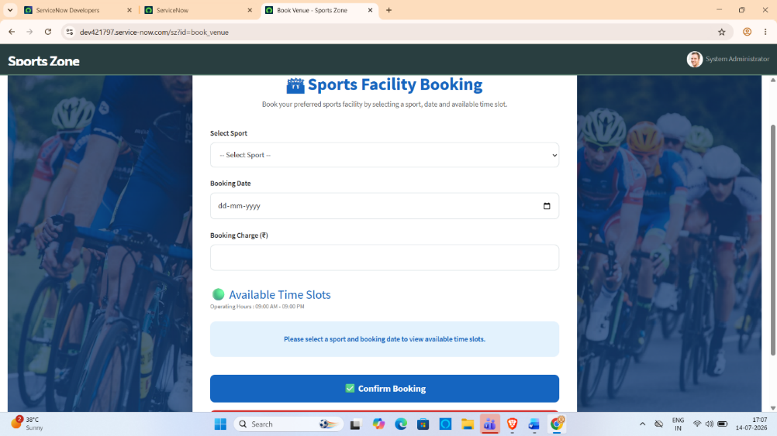

9.4 Available Slot Display

Purpose
The system dynamically displays only the available one-hour booking slots after the user selects a sport and booking date.

Features
- Real-time slot loading
- Already booked slots removed
- Past slots hidden for the current day
- One-hour slot display
- User-friendly card layout
This feature ensures that users can only select valid and available booking slots.
Screenshot
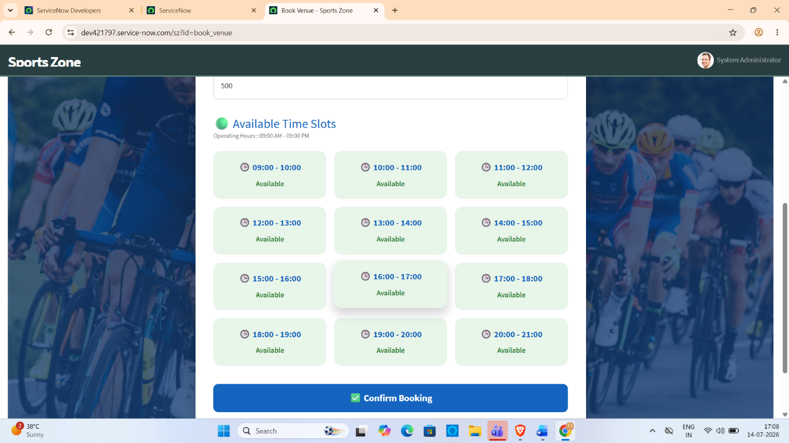

9.5 Booking Confirmation

Purpose
After successful booking, the system displays a confirmation message and redirects the user to the Sports Zone Home Page.

Features
- Success message
- Duplicate booking warning
- Error handling
- Automatic redirection
Screenshot
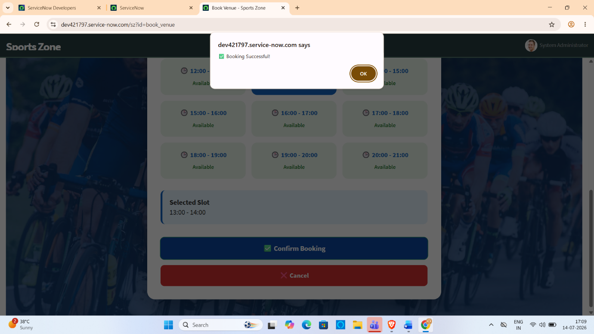

9.6 My Bookings Page

Purpose
The My Bookings page allows users to view the bookings they have created.

Features
- Displays booking history
- Shows sport name
- Booking date
- Booking time
- Booking charge
- Booking status
- Payment status
This page enables users to track their reservations conveniently.
Screenshot
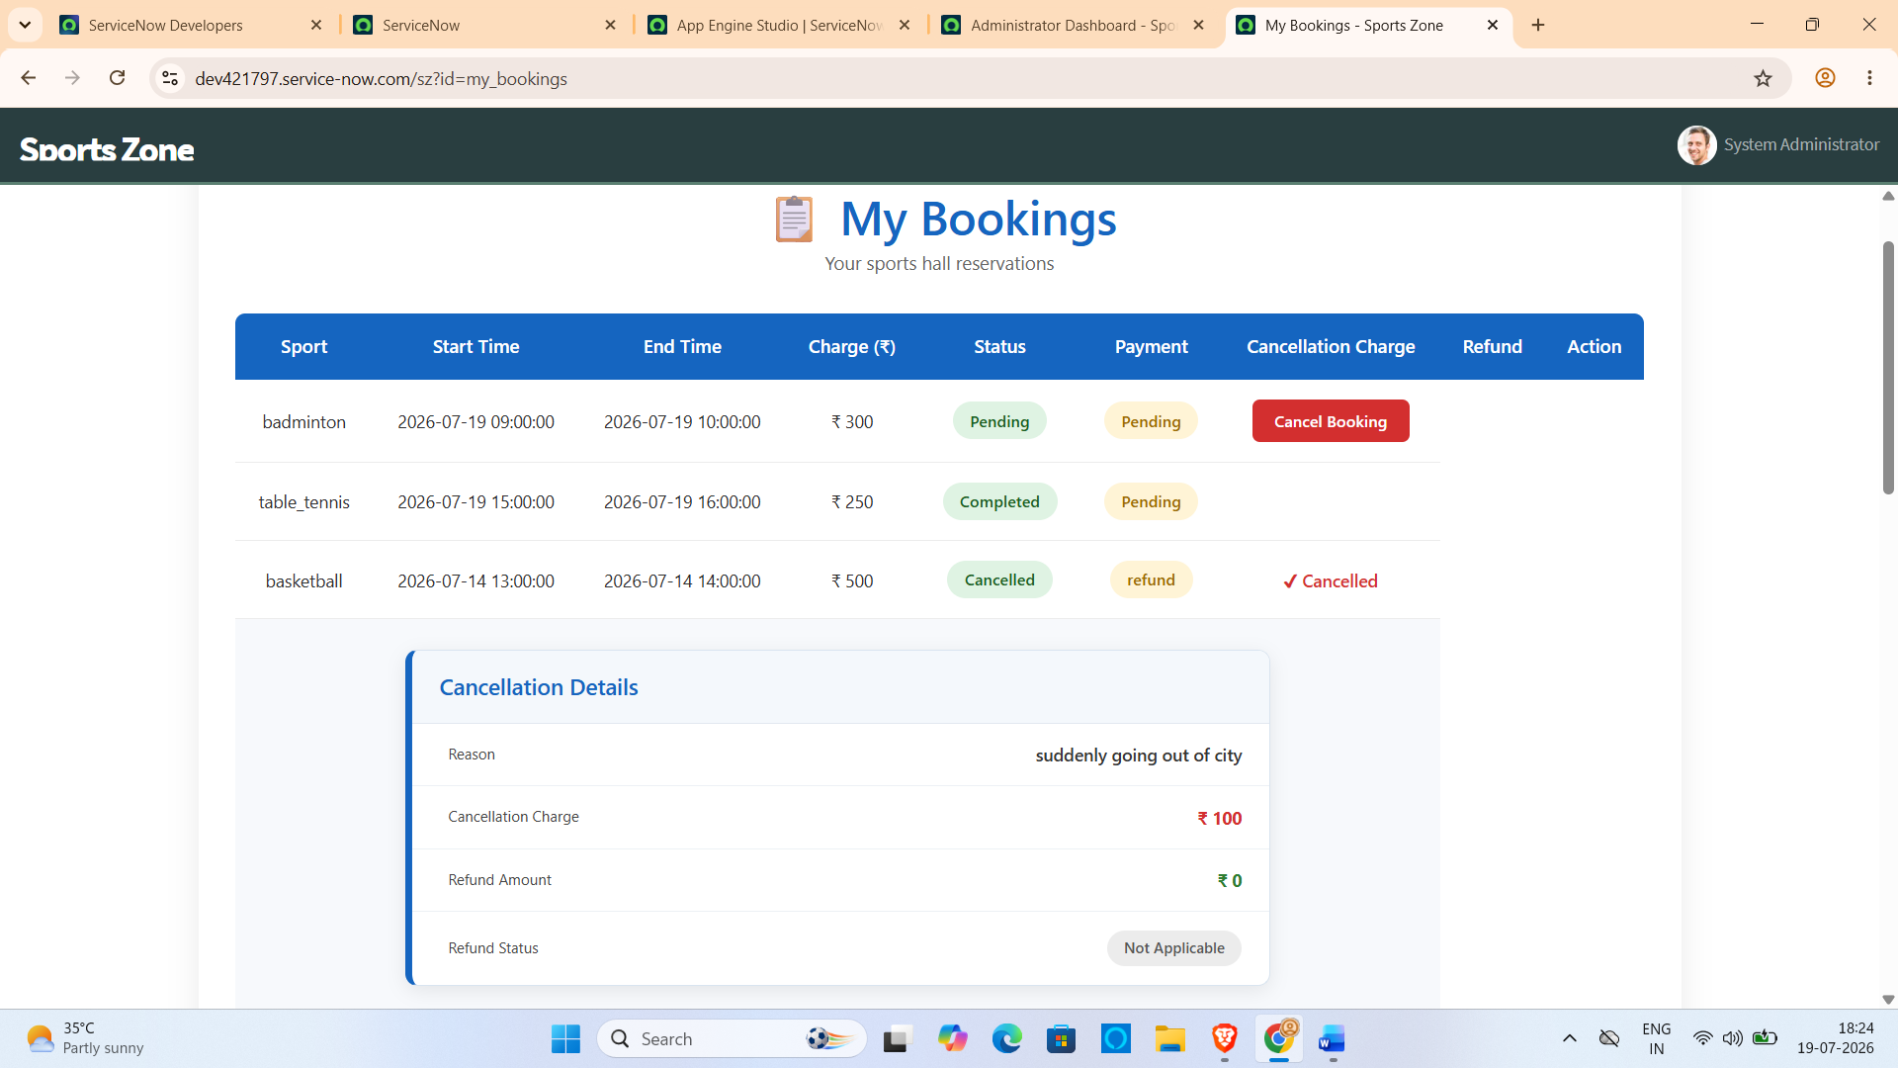
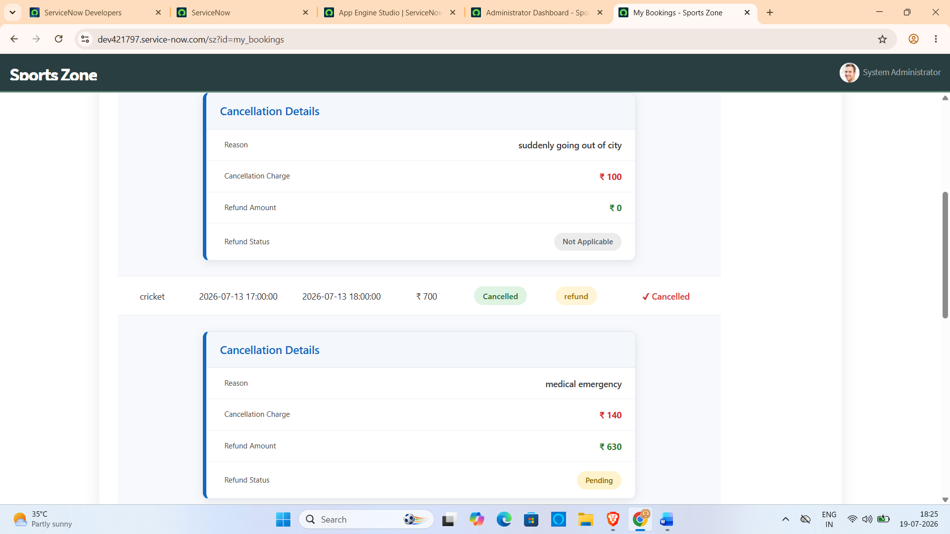

9.7 Contact Page

Purpose
The Contact page provides users with contact information for support related to sports hall booking.

Features
- Contact details
- Email information
- Phone number
- Support information
- Clean interface
Screenshot
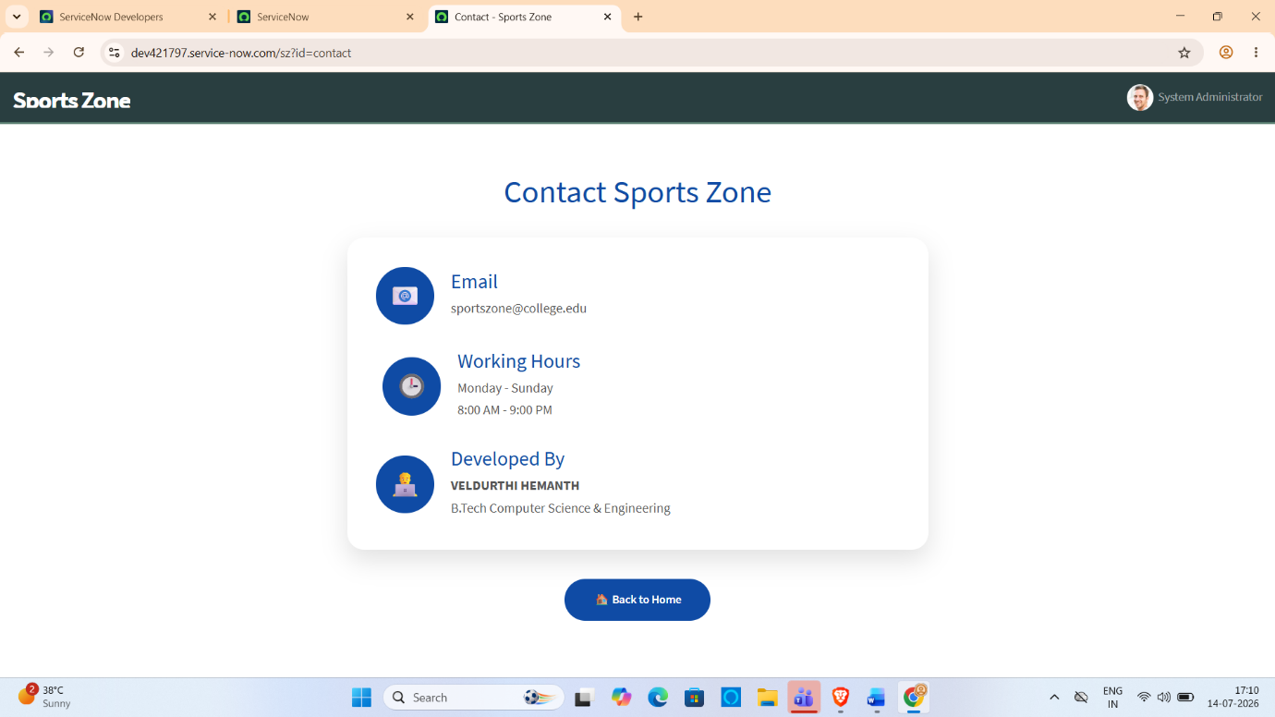

Administrator Dashboard Module

1. Module Overview
The Administrator Dashboard is the central control panel of the Sports Hall Booking System. It provides administrators with a single interface to monitor all booking activities, manage booking requests, process refunds, and supervise the overall operation of the sports hall reservation system.
Unlike the user portal, the administrator dashboard provides additional privileges such as approving or rejecting bookings, completing reservations, managing refund requests, monitoring payment status, viewing booking statistics, and enabling or disabling sports halls.

Objectives
The Administrator Dashboard was developed to achieve the following objectives:
- Monitor all sports hall bookings.
- Approve or reject booking requests.
- Complete or cancel approved bookings.
- Monitor payment status of each booking.
- Process refund requests for cancelled bookings.
- Display booking statistics through dashboard cards.
- Enable or disable sports halls.
- Improve administrative efficiency by managing the entire booking system from one interface.

Administrator Dashboard Features
The dashboard contains four major modules.

Dashboard
Displays overall statistics of the booking system.
Dashboard cards include:
- Total Bookings
- Pending Bookings
- Approved Bookings
- Cancelled Bookings
- Completed Bookings
- Today's Revenue
- Pending Refunds
- Most Booked Sport
The dashboard automatically calculates these values whenever the page is loaded using GlideRecord queries.
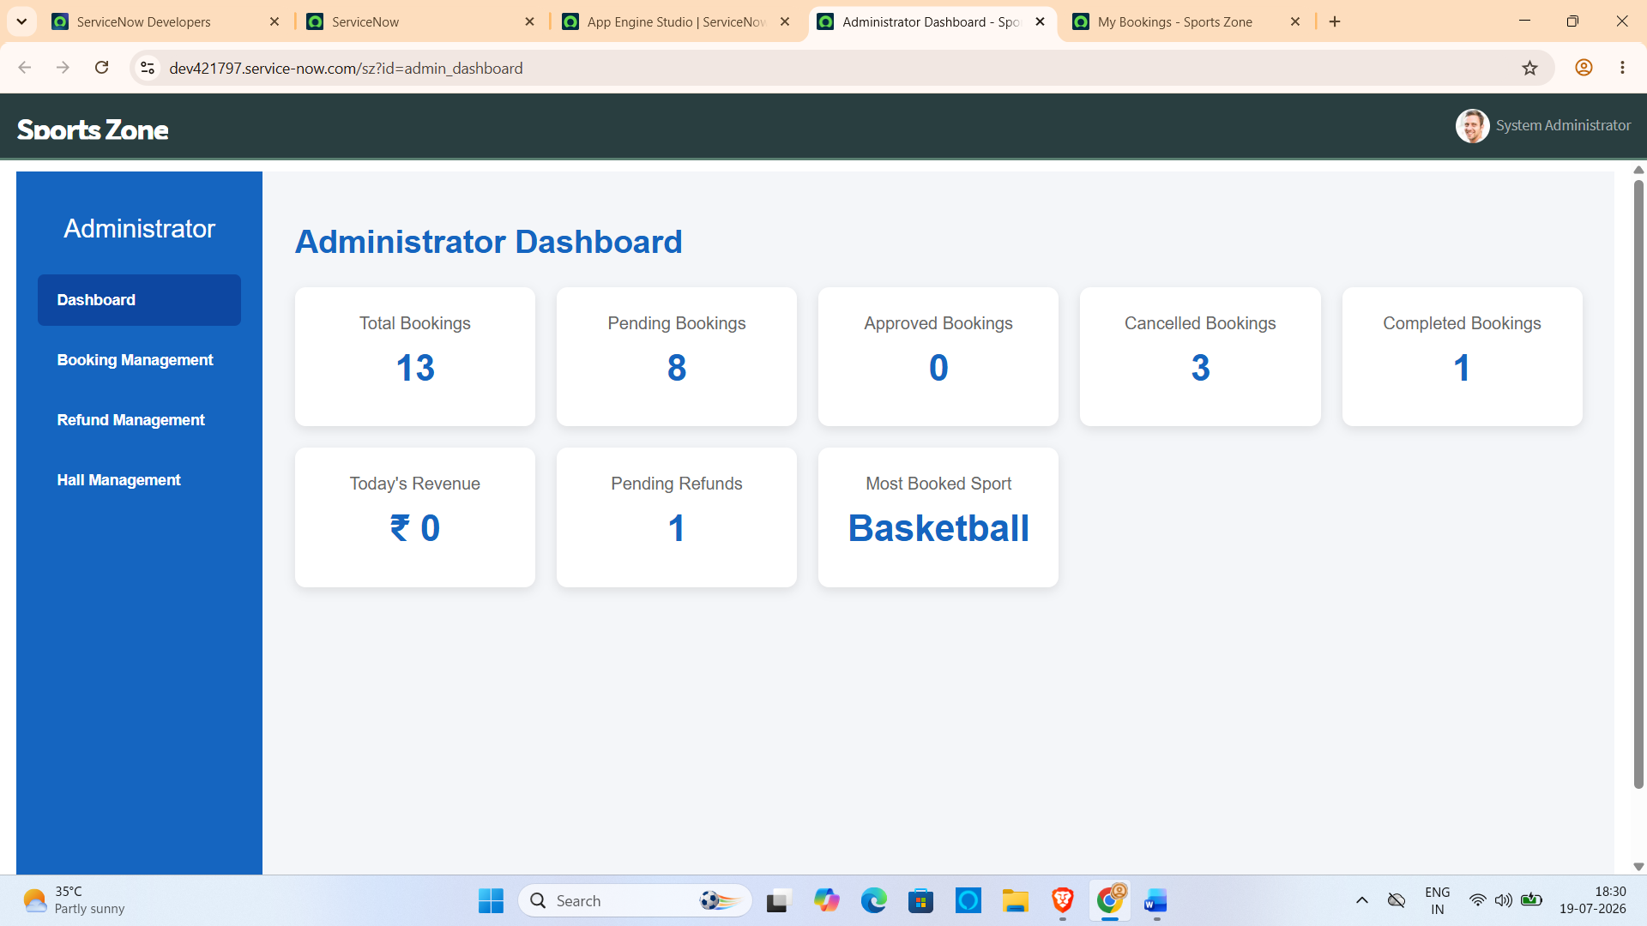

Booking Management
Allows the administrator to manage every booking made by users.
Displayed Information:
- User Name
- Sports Hall
- Booking Start Time
- Booking Charge
- Booking Status
- Payment Status
Administrative Actions:
- Approve Booking
- Reject Booking
- Complete Booking
- Cancel Booking
- Mark Payment as Paid (if payment is pending)
Whenever an action is performed, the corresponding booking record is updated instantly in the database.
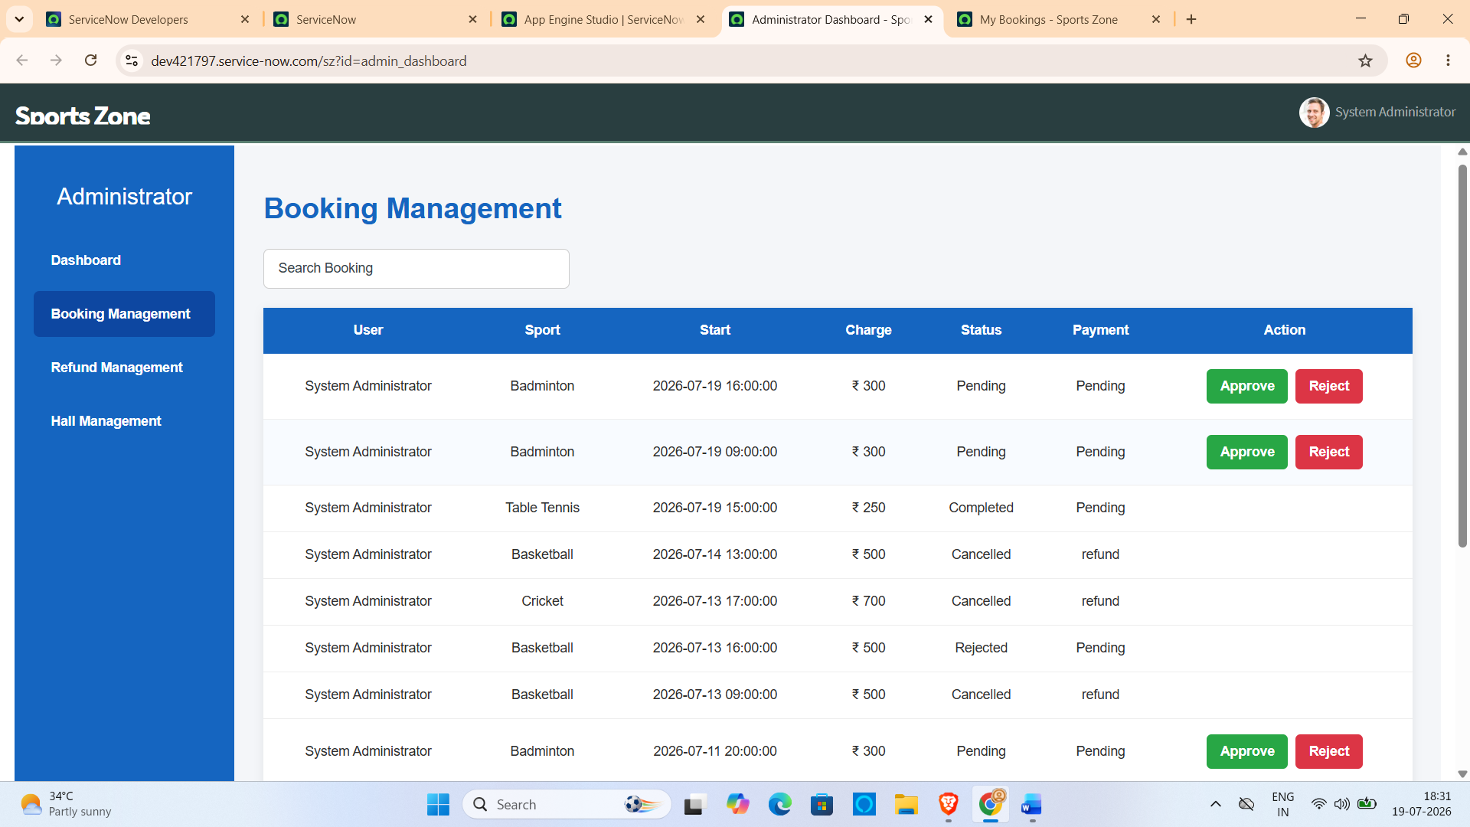

Refund Management
The refund module handles cancellation refunds.
Displayed Information:
- User Name
- Sports Hall
- Cancellation Reason
- Cancellation Charge
- Refund Amount
- Refund Status
Administrative Actions:
- Approve Refund
When the administrator approves a refund:
- Refund Status changes from Pending to Refunded.
- Refund information is permanently stored in the booking record.
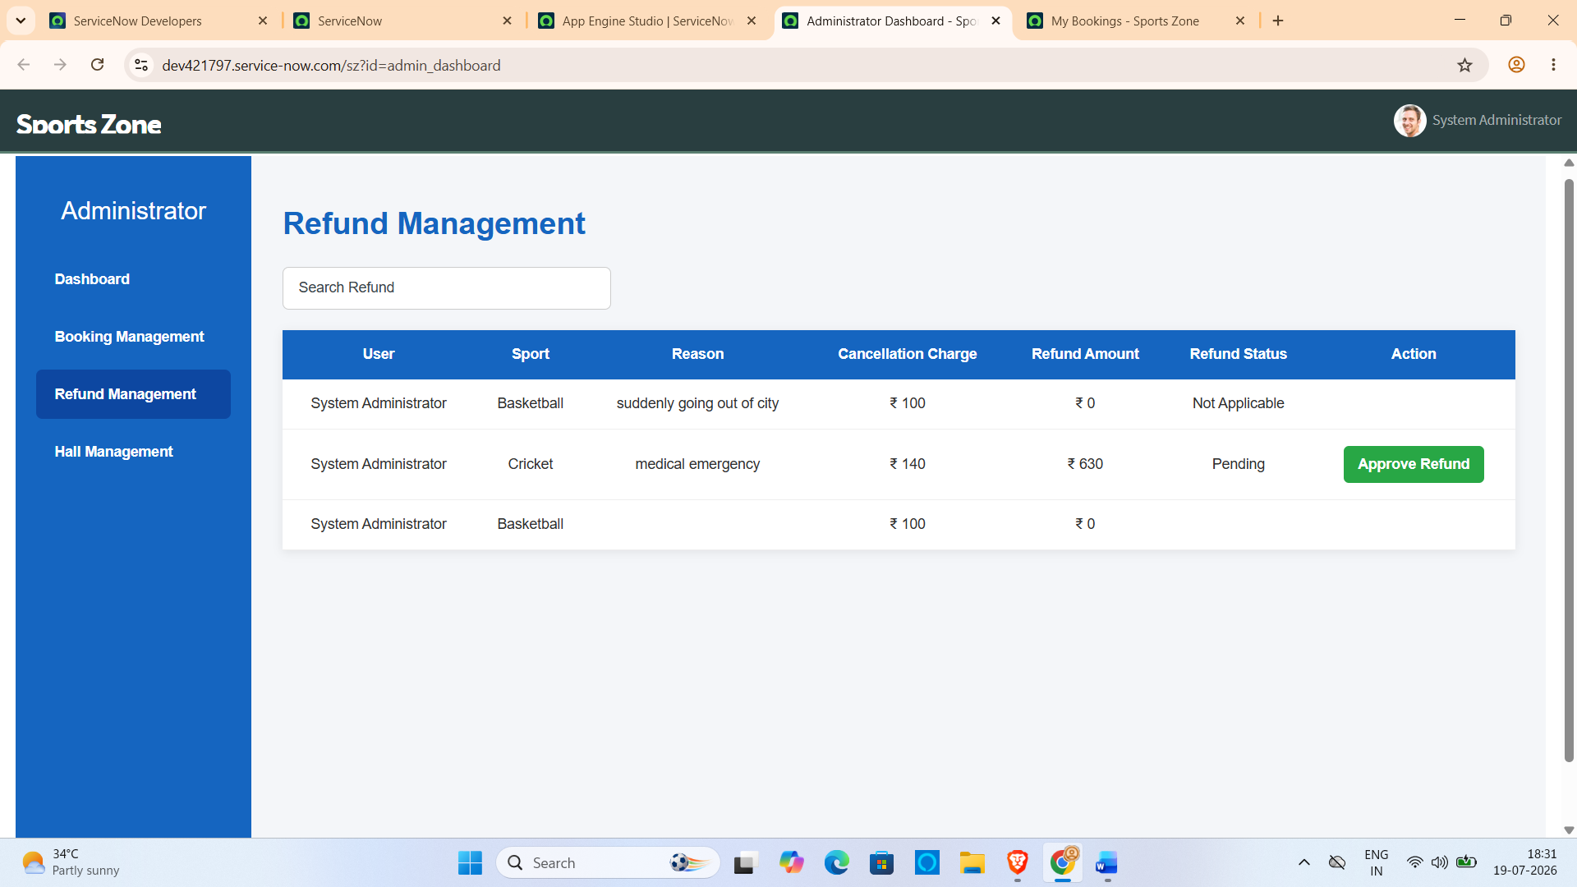

Sports Hall Management
The Sports Hall Management section enables the administrator to control the availability of sports halls.
The administrator can:
- Enable Basketball Hall
- Disable Basketball Hall
- Enable Badminton Hall
- Disable Badminton Hall
- Enable Table Tennis Hall
- Disable Table Tennis Hall
- Enable Volleyball Hall
- Disable Volleyball Hall
- Enable Cricket Hall
- Disable Cricket Hall
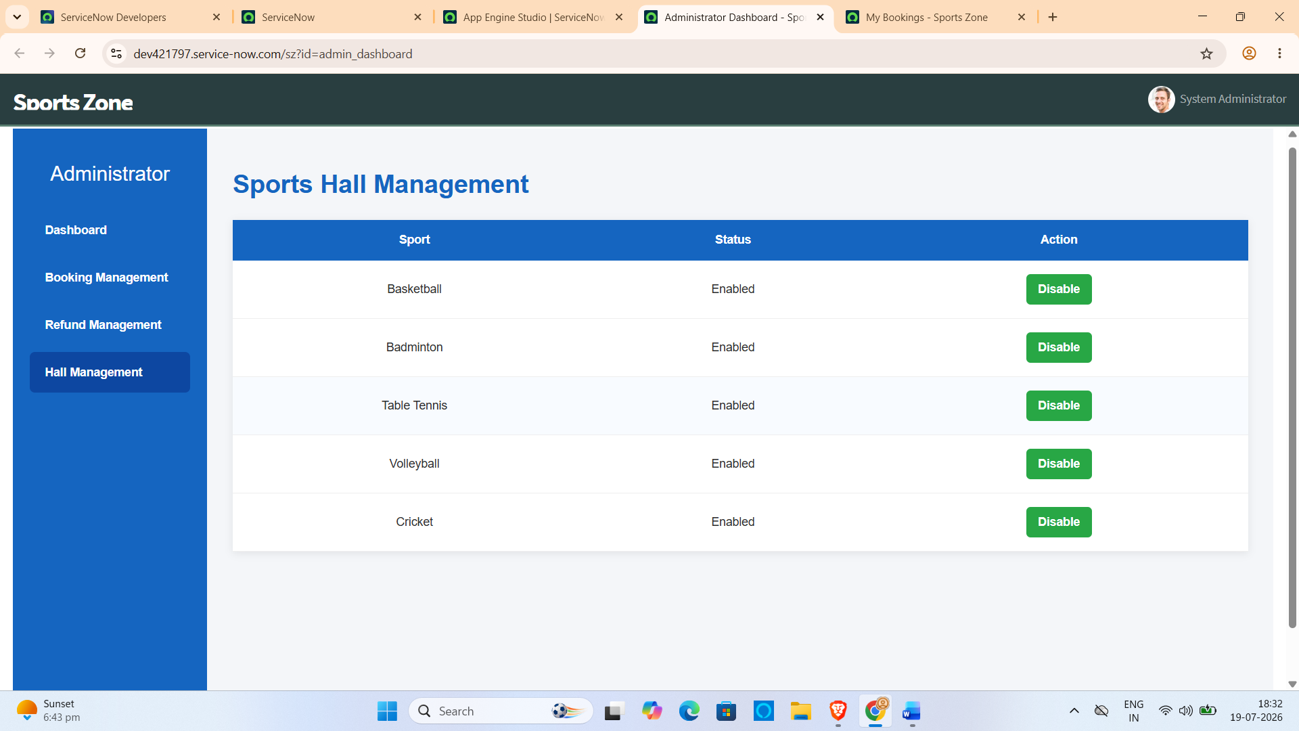

9.8 User Interface Components
Component | Purpose
Navigation Bar | Navigate between pages
Sports Dropdown | Select preferred sport
Date Picker | Select booking date
Booking Charge | Display booking amount
Available Slots | Display free booking slots
Book Now Button | Confirm booking
Cancel Button | Return to Home Page
Success Message | Booking confirmation
Error Message | Validation feedback

9.9 User Interface Workflow
User
↓
Sports Zone Home Page
↓
Book Venue Page
↓
Select Sport
↓
Choose Date
↓
Available Slots Displayed
↓
Select Slot
↓
Book Now
↓
Booking Confirmation
↓
My Bookings Page

9.10 User Experience
The user interface was designed to provide a smooth and intuitive booking experience. Clear navigation, responsive layouts, real-time slot updates, and simple booking steps reduce user effort and improve overall usability. The interface enables users to complete a sports hall reservation within a few simple steps while ensuring accuracy and preventing duplicate bookings.

10. TESTING

10.1 Testing Overview
Testing was performed throughout the development of the Sports Hall Booking System to ensure that all modules function correctly and meet the project requirements. The application was tested for functionality, usability, data validation, and system performance. Each feature was verified individually before integrating it into the complete system.
The testing process ensured that users could successfully book sports halls, view available slots, prevent duplicate bookings, and receive appropriate system responses.

10.2 Testing Strategy
The following testing strategy was adopted during the project development.
Testing Type | Purpose
Functional Testing | Verify application features
User Interface Testing | Validate portal pages and widgets
Database Testing | Verify booking records
Validation Testing | Prevent invalid bookings
Performance Testing | Check system response
User Acceptance Testing | Verify user requirements

10.3 Functional Testing
The major functional modules were tested individually.
Module | Expected Result | Status
Sports Selection | Sport selected successfully | Passed
Booking Date Selection | Date selected correctly | Passed
Available Slot Display | Only available slots displayed | Passed
Booking Charge Display | Correct charge displayed | Passed
Booking Creation | Booking created successfully | Passed
Duplicate Booking Validation | Duplicate booking prevented | Passed
Booking Confirmation | Confirmation displayed | Passed
My Bookings | Booking records displayed | Passed
Contact Page | Contact information displayed | Passed

10.4 Validation Testing
The system validates user input before processing booking requests.

Validations Performed
- Sport must be selected.
- Booking date is mandatory.
- Booking slot must be selected.
- Already booked slots cannot be booked again.
- Booking information must be complete.
- Booking charge should match the selected sport.
These validations ensure accurate and reliable booking records.

10.5 Database Testing
Database testing was performed to verify that booking information is stored correctly.

Verified Items
- Booking record inserted successfully.
- Hall name stored correctly.
- Booking date stored correctly.
- Start time and end time stored correctly.
- Booking charge stored correctly.
- Logged-in user stored correctly.
- Booking status updated correctly.
- Payment status saved successfully.

10.6 Performance Testing
The application was tested under normal usage conditions.

Parameters Tested
Parameter | Result
Portal Loading | Successful
Slot Loading | Fast response
Booking Processing | Successful
Database Response | Stable
User Interface | Responsive
Navigation | Smooth
The application performed efficiently without noticeable delays during booking operations.

10.7 Error Handling
The application properly handles common errors and displays meaningful messages.

Errors Handled
- Sport not selected.
- Booking date not selected.
- Slot not selected.
- Duplicate booking attempt.
- Invalid booking request.
- Database insertion failure.
Appropriate success or error messages are displayed to the user for each situation.

10.8 Testing Tools Used
Tool | Purpose
ServiceNow PDI | Application Testing
Service Portal | User Interface Testing
System Logs | Debugging
GlideRecord | Database Verification
Browser Developer Tools | Client-side Validation
Google Chrome | Application Execution

10.9 Testing Summary
The Sports Hall Booking System was successfully tested for all major functionalities. The testing confirmed that the application correctly handles booking creation, prevents duplicate bookings, displays only available slots, stores booking records securely, and provides a smooth user experience. No critical issues remained after completing the testing phase.

11. SCREENSHOTS OR DEMO

11.1 Application Overview
The following screenshots demonstrate the major functionalities of the Sports Hall Booking System developed using the ServiceNow Service Portal. These screenshots illustrate the complete booking process, user interface, and successful execution of different modules.

11.2 Sports Zone Home Page

Description
The Sports Zone Home Page is the landing page of the application. It provides users with easy navigation to different modules such as Book Venue, My Bookings, and Contact. The page serves as the entry point for accessing all booking services.
Screenshot:
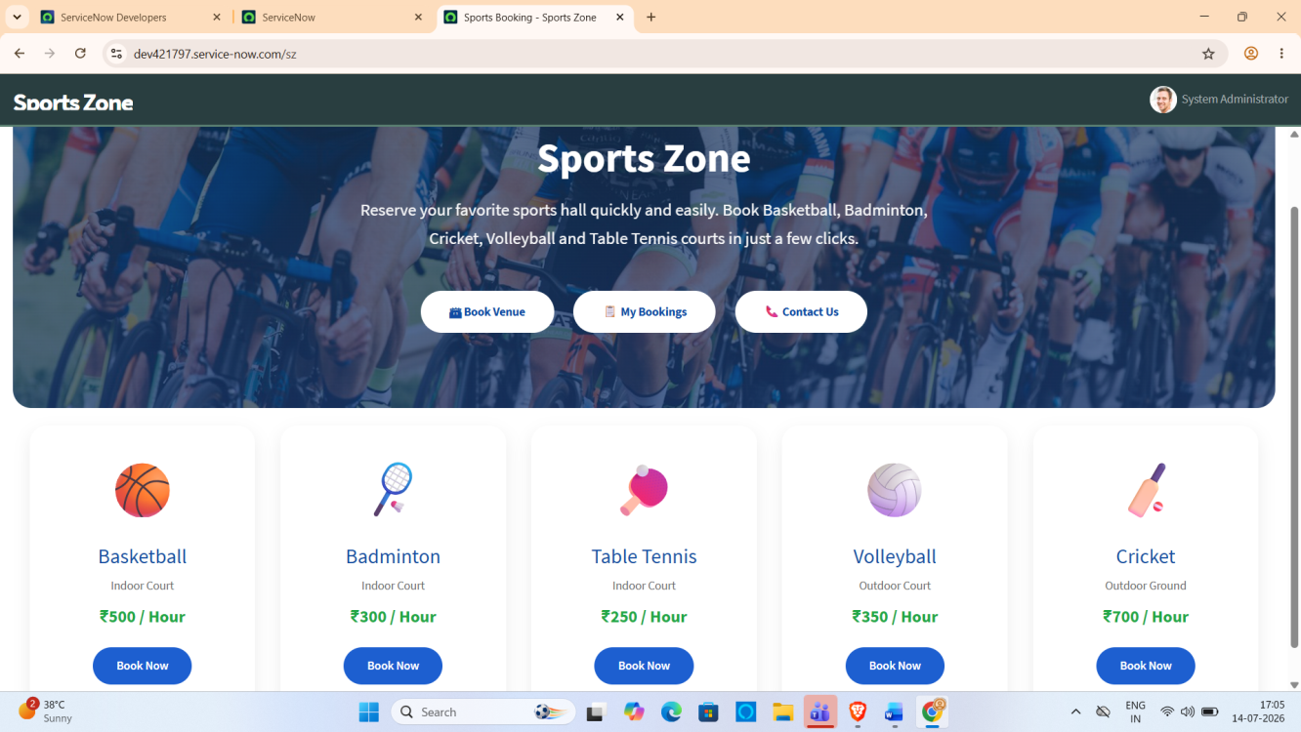

11.3 Book Venue Page

Description
The Book Venue page allows users to reserve sports halls by selecting the desired sport, booking date, and available time slot. The page also displays the booking charge automatically based on the selected sport.
Screenshot:
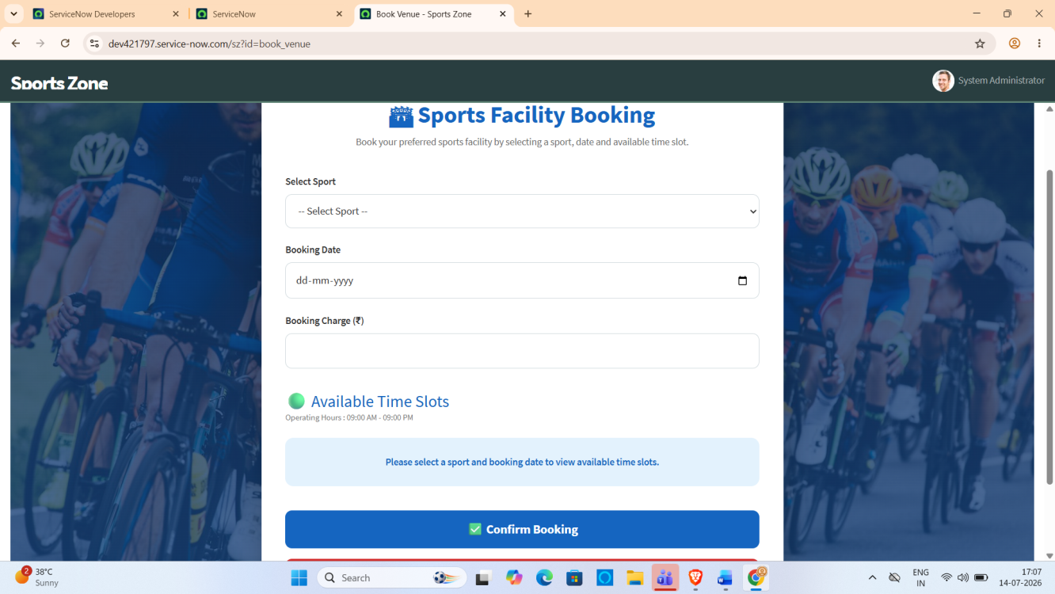

11.4 Available Slot Display

Description
After selecting the sport and booking date, the system dynamically displays only the available one-hour booking slots. Previously booked slots are automatically removed from the available list, preventing duplicate bookings.
Screenshot:
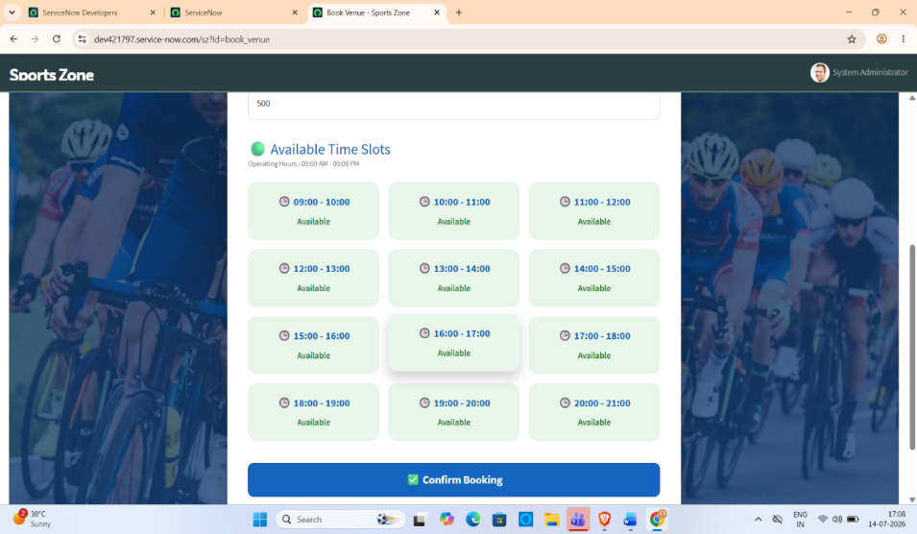

11.5 Successful Booking

Description
Once the user selects an available slot and clicks the Book Now button, the booking is validated and stored successfully. A confirmation message is displayed, indicating that the reservation has been completed.
Screenshot:
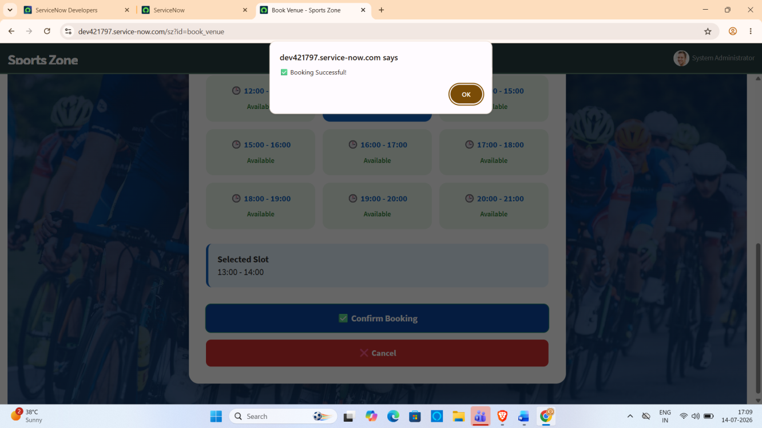

11.6 My Bookings Page

Description
The My Bookings page displays the bookings created by the logged-in user. It includes booking details such as sport name, booking date, booking time, booking charge, booking status, and payment status.
Screenshot:
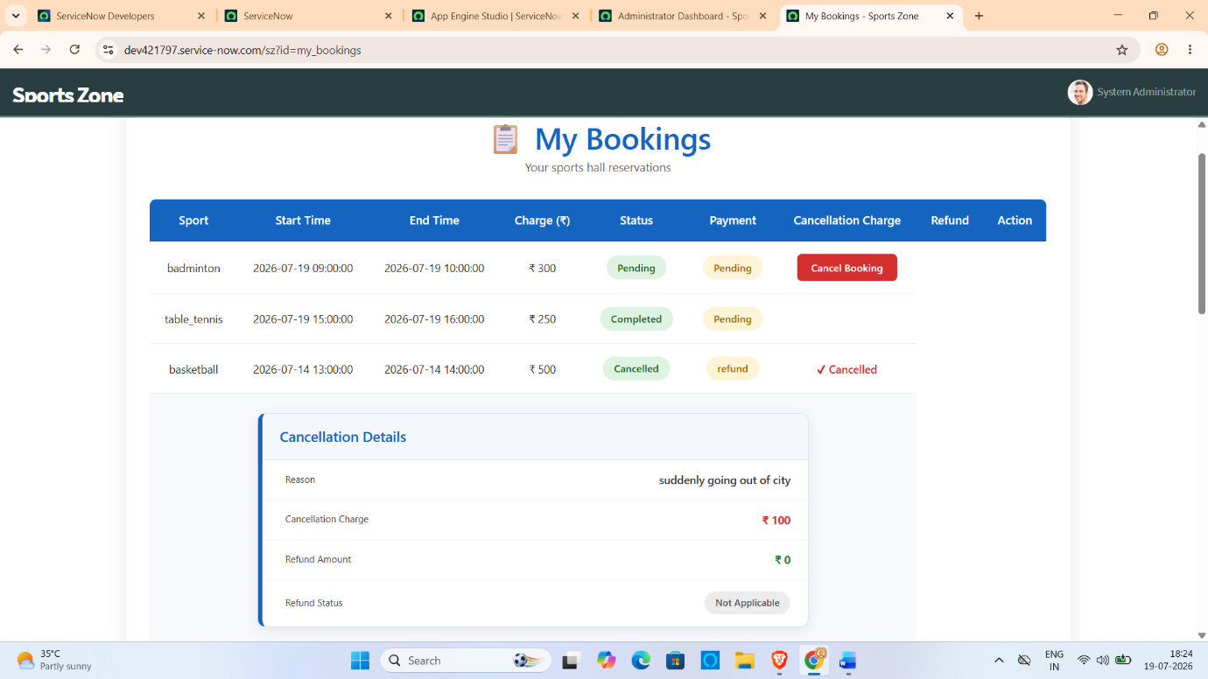
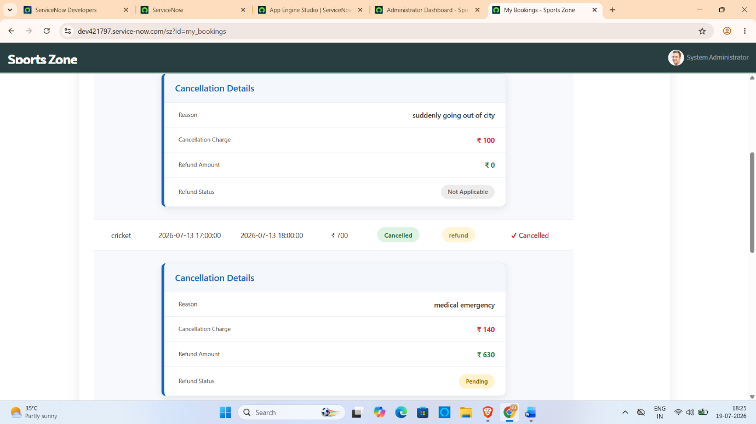

11.7 Contact Page

Description
The Contact page provides users with support information and contact details for resolving issues related to sports hall booking.
Screenshot:
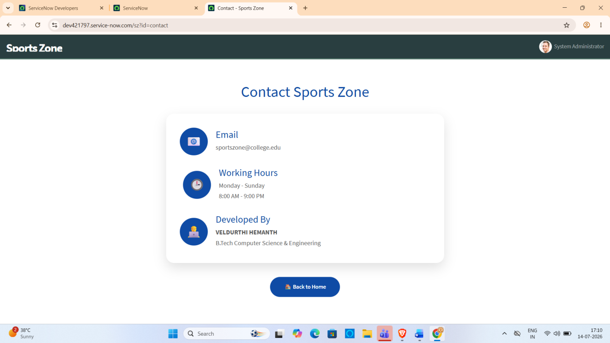

11.8 Sports Hall Booking Table

Description
The custom Sports Hall Bookings table stores all booking records created through the Service Portal. Each record contains sport name, booking date, booking time, booking charge, booking status, payment status, and user information.
Screenshot:
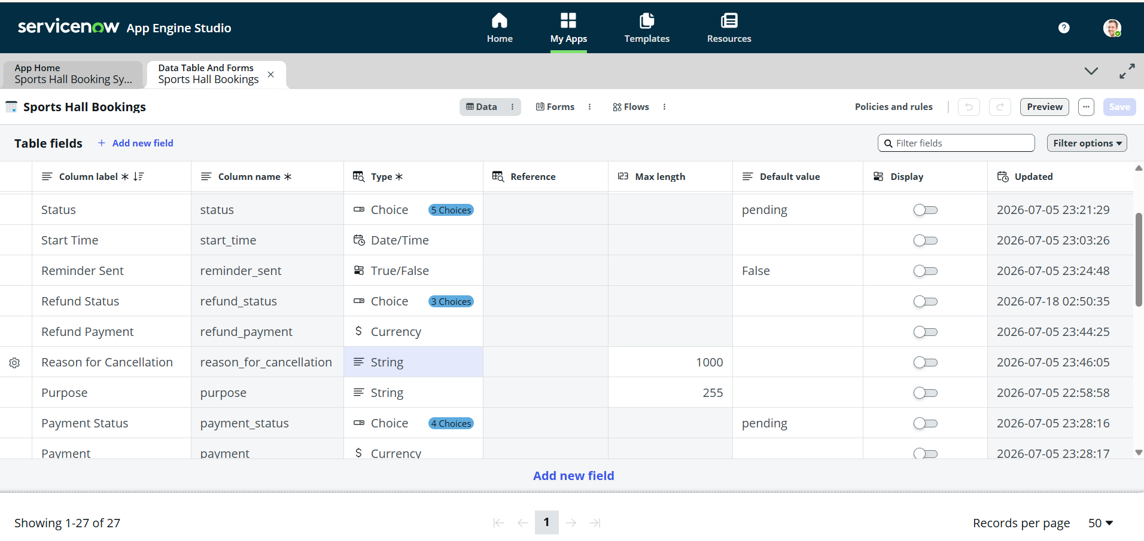
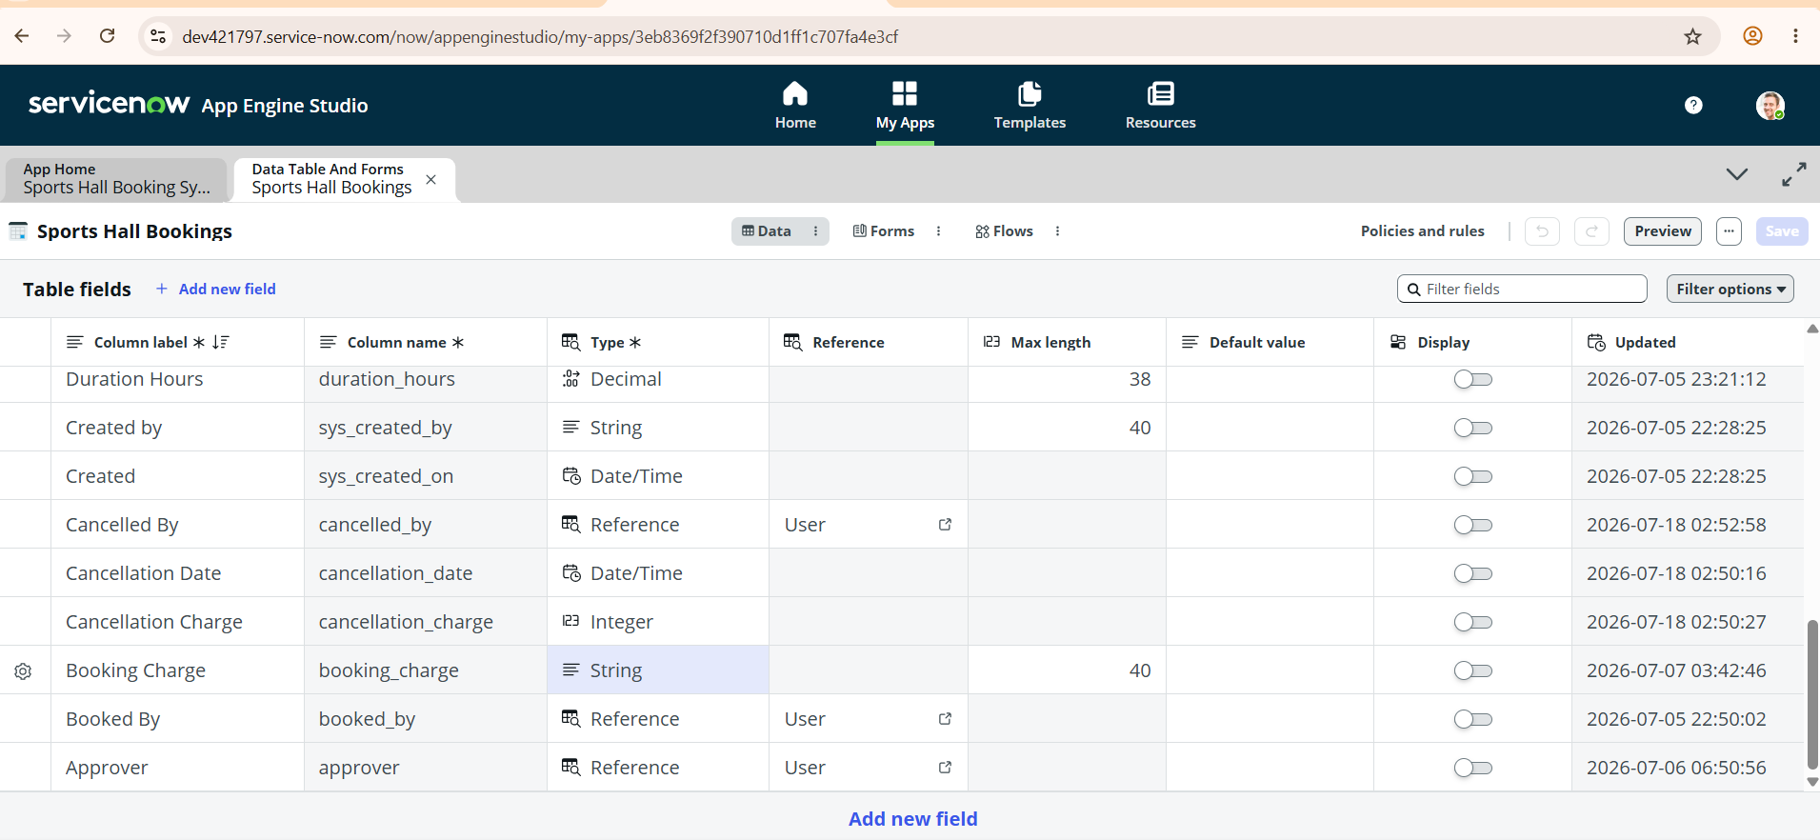

11.9 Flow Designer

Description
Flow Designer automates booking-related activities such as booking confirmation and reminder processing. The implemented flows improve automation and reduce manual intervention.
Screenshot:
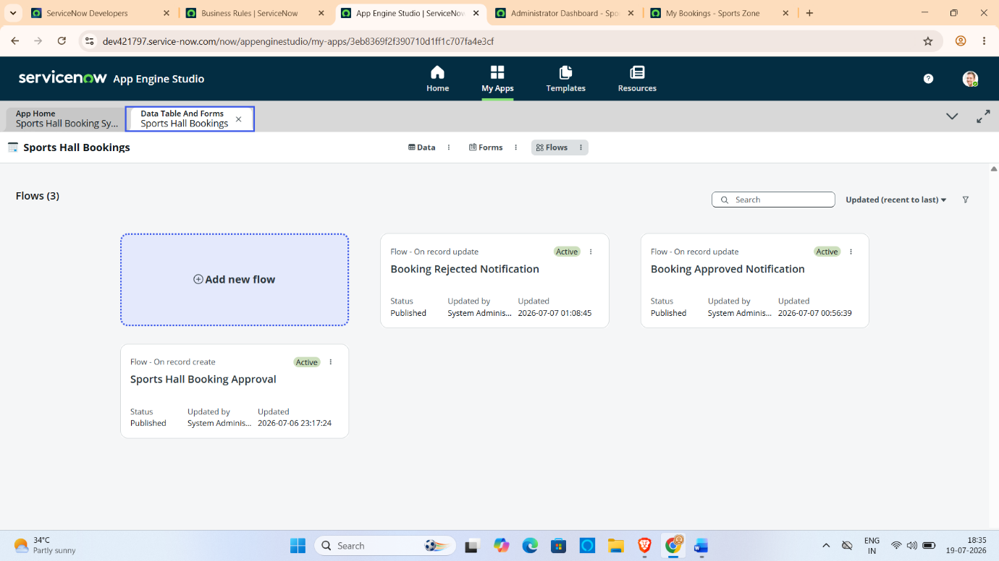

11.10 Email Notifications

Description
Email Notifications were configured to automatically inform users about successful bookings and booking reminders. These notifications improve communication between the system and users.
Screenshot:
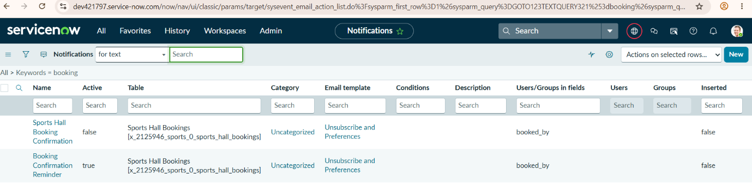

11.11 Event Registry

Description
Custom events such as sports.hall.confirmation and sports.hall.reminder were created to trigger automated notification workflows.
Screenshot:
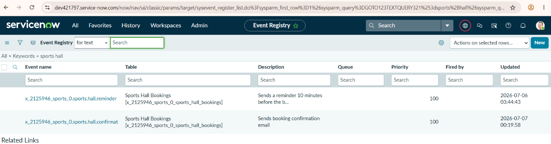

11.12 Business Rules

Description
Business Rules were implemented to validate bookings, prevent duplicate reservations, and maintain data consistency within the application.
Screenshot:



11.13 Project Demonstration
A complete demonstration of the Sports Hall Booking System has been prepared to showcase the application workflow, including portal navigation, sports selection, booking creation, available slot management, duplicate booking prevention, and successful reservation.
Project Demo Link:
https://drive.google.com/file/d/1H3SrzRsxqNMEqnidK_ZEi1Y1MiUkgKVE/view?usp=drive_link

12. KNOWN ISSUES

12.1 Overview
The Sports Hall Booking System was successfully developed and tested using the ServiceNow Service Portal. All major functionalities, including sports selection, slot availability, booking validation, duplicate booking prevention, and booking confirmation, are working as expected. However, a few limitations remain that can be addressed in future versions of the application.

12.2 Known Limitations
Issue ID | Known Issue / Limitation | Impact | Possible Solution
KI-01 | Online payment gateway is not integrated. | Users cannot make payments through the portal. | Integrate payment gateways such as Razorpay or Stripe.
KI-02 | Booking cancellation is not automated. | Users need administrator support for cancellation. | Implement a self-service cancellation feature.
KI-03 | The application currently supports only predefined one-hour booking slots. | Users cannot choose custom booking durations. | Allow flexible booking time selection.
KI-04 | Booking reminders are limited to email notifications. | Users may miss reminders if they do not check email. | Add SMS or mobile push notifications.

12.3 Challenges Faced During Development
During the implementation of the project, several technical challenges were encountered and resolved successfully.
- Displaying only available booking slots.
- Handling ServiceNow time zone differences.
- Preventing duplicate bookings.
- Configuring Flow Designer correctly.
- Setting up Event Registry and Email Notifications.
- Debugging Client Controller and Server Script.
- Integrating Service Portal widgets with the custom database.
These challenges were resolved through testing, debugging, and proper configuration of ServiceNow components.

12.4 Summary
The current version of the Sports Hall Booking System meets all the functional requirements specified for the SmartBridge internship project. The identified limitations do not affect the core functionality of the application and can be considered future enhancements to improve usability, scalability, and user experience.

13. FUTURE ENHANCEMENTS

13.1 Overview
The current version of the Sports Hall Booking System successfully automates the sports hall reservation process using the ServiceNow Service Portal. Although all core functionalities have been implemented and tested successfully, several additional features can be incorporated in future versions to improve usability, automation, scalability, and overall user experience.

13.2 Proposed Future Enhancements

1. Online Payment Integration
The current application displays booking charges but does not support online payment. Future versions can integrate secure payment gateways such as Razorpay, Stripe, or PayPal to allow users to complete payments during the booking process.

2. Mobile Application
A dedicated Android or iOS application can be developed using ServiceNow Mobile App Builder or cross-platform frameworks to enable users to make bookings from their smartphones.

3. QR Code Based Entry
Each successful booking can generate a unique QR code. Sports administrators can scan the QR code at the entrance to verify reservations and reduce manual verification.

4. SMS and Push Notifications
The current system supports email notifications. Future versions can integrate SMS services or mobile push notifications to remind users about their upcoming bookings.

5. Multi-Organization Support
The current application is designed for a single institution. Future versions can support multiple organizations, colleges, or sports complexes through role-based access and organization-specific configurations.

6. Advanced Reporting
Interactive reports and dashboards can be generated to analyze:
- Daily bookings
- Monthly bookings
- Most popular sports
- Peak booking hours
- Revenue generated
- User activity
These reports will help administrators make better decisions regarding sports facility management.

7. AI-Based Slot Recommendation
Artificial Intelligence can be integrated to recommend the best available booking slots based on previous booking history, user preferences, and hall utilization patterns.

13.3 Future Scope Summary
Enhancement | Expected Benefit
Online Payment Gateway | Secure digital payments
Mobile Application | Access from anywhere
QR Code Verification | Faster entry validation
SMS & Push Notifications | Instant reminders
Analytics & Reports | Better decision making
Multi-Organization Support | Scalability
AI Slot Recommendation | Personalized user experience
Cloud Integration | Improved performance and availability

13.4 Conclusion
The Sports Hall Booking System using ServiceNow Service Portal successfully demonstrates how enterprise application development can simplify and automate sports facility management. The project replaces the traditional manual booking process with an efficient digital platform that provides real-time slot availability, duplicate booking prevention, automated workflows, and secure record management.
The application fulfills the objectives of the SmartBridge internship by showcasing the practical implementation of ServiceNow technologies, including Service Portal, Widgets, Client Controllers, Server Scripts, GlideRecord API, Business Rules, Flow Designer, Event Registry, Email Notifications, and Scheduled Jobs.
With the proposed future enhancements, the system can be expanded into a comprehensive sports facility management solution capable of serving educational institutions, sports academies, and recreational organizations.

